Gigaset A540 Analogue Cordless Phone

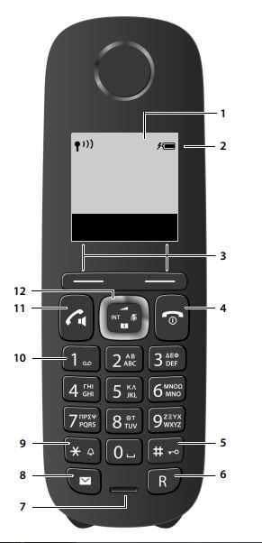

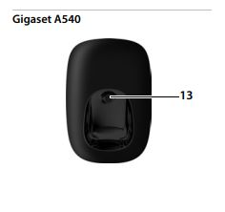

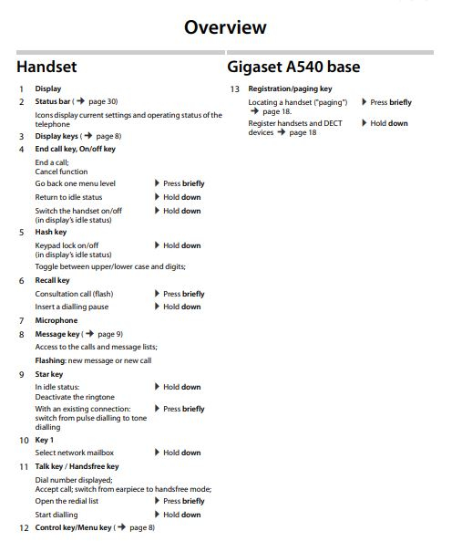

Basic Instructions

How to make a call?

For external calls:
Enter 0 and the number on the keypad, then press the Talk Key to connect.
To end the call, press the End key.

For internal calls:
Enter the 3-digit internal number on the keypad, then press the Talk key to connect.
To end the call, press the End key.

How to redial a number you called?
Press the Talk key once, list will display of dialled calls, scroll down with arrow up and down 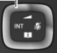key, to highlight, then press the Talk key to dial the number.

How to answer an incoming call?
Press the Talk Key to accept the call

If auto answer is enabled, pick up the phone from the cradle and the call is answered.

Basic Instructions

How to transfer an incoming call to another phone?
Whilst on a call-in progress, press the R key, then you hear system tone, dial the number you wish to transfer to, the other party answers, then press the End key to transfer.

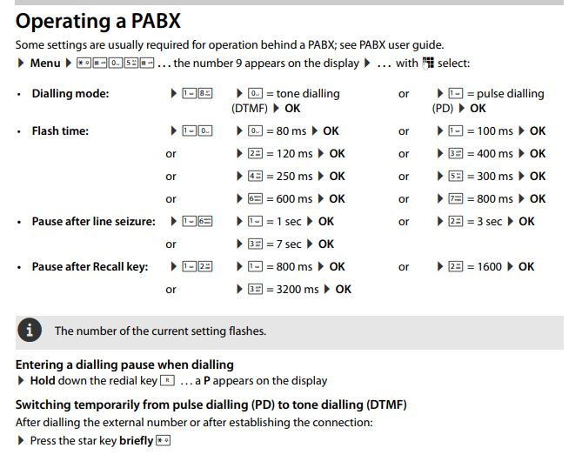

For Technical Support, please call Nu Teck Communications: 02 9647 3333

